**E115 – Programming and Data Analysis**

**Individual log sheet for Week 04**

1. Import the raw data for Project 2 into a new Excel workbook. The raw data can be found in the files “Week-1.txt”, “Week-2.txt”, “Week-3.txt”, “Week-4.txt”, “Week-5.txt”, “Week-6.txt”, “Week-7.txt” and “Week-8.txt”.

After importing, you should have 8 Excel sheets (one for each text file) within one single Excel file. You will be working with this Excel file from Weeks 4 to 7.

1. Write a macro to clean up the data by removing all the rows with missing data or garbage data.

Answer:

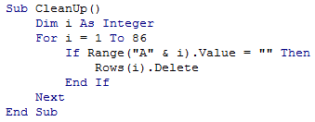

1. Select a table header from the following 3 table headers. Each member of the team should choose a different table to work on.

Fill in the data for your selected table in Excel.

|  |  |  |
| --- | --- | --- |
| **Week 1** | | |
| **Item** | **Sales revenue** |

Answer: First, sort the table based on “Item”.

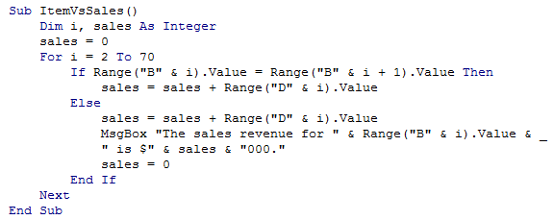

|  |  |
| --- | --- |
| **Item** | **Sales revenue** |
| Shampoo & Conditioner | $74,000 |
| Styling cream | $158,000 |
| Body lotion | $242,000 |
| Body wash | $120,000 |
| Fragrance | $378,000 |
| Hand, foot, nail | $166,000 |
| Soap | $81,000 |
| Anti-aging | $137,000 |
| Cleanser | $183,000 |
| Eye treatment | $68,000 |
| Moisturizer | $177,000 |
| Sun protection | $210,000 |
| Blush | $75,000 |
| Eyeshadow | $125,000 |
| Foundation | $247,000 |
| Lipstick | $137,000 |
| Mascara | $161,000 |
| Powder | $148,000 |

|  |  |  |
| --- | --- | --- |
| **Week 2** | | |
| **Item** | **Sales revenue** |

Answer similar to part (a), but using Week 2 data.

|  |  |  |
| --- | --- | --- |
| **Week 1** | | |
| **Category** | **Sales revenue** |

Answer: First, sort the table based on “Category”.

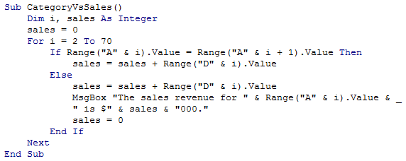

|  |  |
| --- | --- |
| **Category** | **Sales revenue** |
| Hair | $232,000 |
| Body | $987,000 |
| Face | $775,000 |
| Makeup | $893,000 |

|  |  |  |
| --- | --- | --- |
| **Week 2** | | |
| **Category** | **Sales revenue** |

Answer similar to part (c), but using Week 2 data

|  |  |  |
| --- | --- | --- |
| **Week 1** | | |
| **Brand** | **Sales revenue** |

Answer: First, sort the table based on “Brand”.

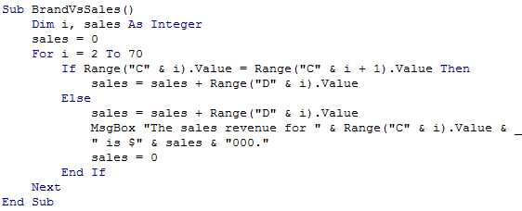

|  |  |
| --- | --- |
| **Brand** | **Sales revenue** |
| Beauty Heaven | $808,000 |
| Cralins | $569,000 |
| Lanchard | $605,000 |
| Lufee | $496,000 |
| Su Mura | $409,000 |

|  |  |  |
| --- | --- | --- |
| **Week 2** | | |
| **Brand** | **Sales revenue** |

Answer similar to part (e), but using Week 2 data

1. Display the data in your selected table using an Excel chart of your choice.